**Strategic Product Placement Analysis: Unveiling Sales Impact with Tableau Visualization**

Introduction*: This project explores how the way a product is positioned in the market affects its sales and how consumers respond to it. Using Tableau, we'll dive into the data to uncover patterns and insights—looking at what types of positioning lead to stronger sales and how they influence customer preferences. By visualizing our findings, we aim to offer clear, practical recommendations that can help improve product positioning strategies and ultimately boost revenue.*

Data Visualization:

*Data visualization means showing information using pictures like charts, graphs, or maps. It helps people understand data more easily by making it clear and simple to see. Instead of looking at lots of numbers, we can quickly see patterns, trends, or anything unusual in the data just by looking at the visuals.*

1.**Avg Sales Volume vs Product Category:**

*The graph shown is in a* ***horizontal bar chart*** *format. This format is used to compare average sales volumes across different product categories visually, with each bar representing a category and its length indicating the average sales value.*

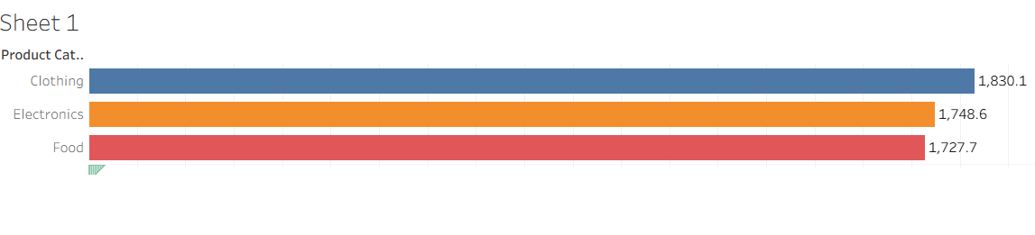

*2.****Competitor Price Vs Price:***

*Graph Name: Competitor Price vs Price. The graph compares product prices with competitor prices across categories. Competitor prices are visibly higher, around 146–150 units. Own product prices are lower, shown by the smaller bars below.*

*Graph Format:* ***Vertical bar chart.***

*This format helps in quickly comparing price differences between your products and competitor off b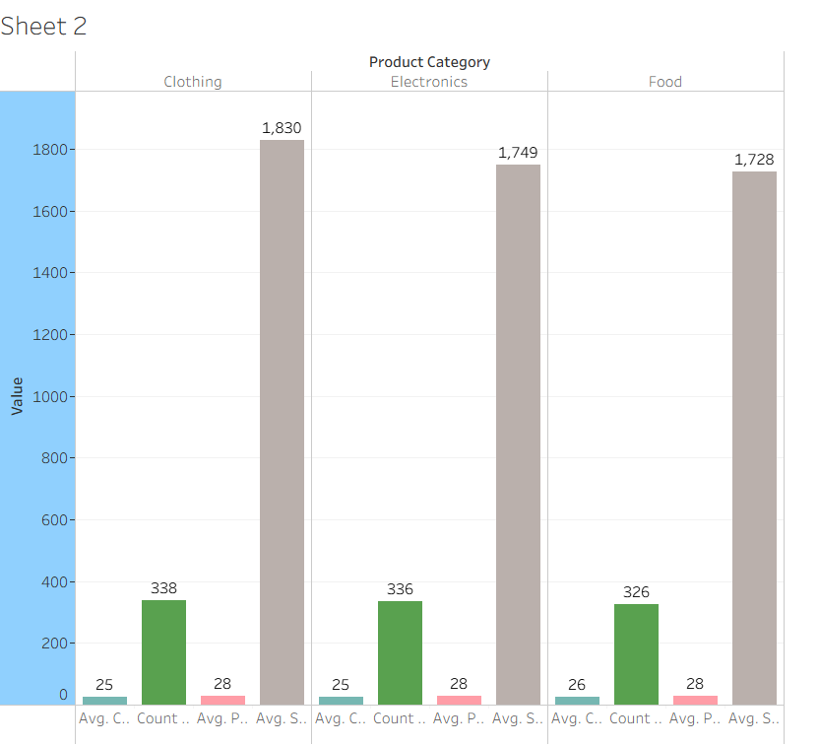*

*3****.* *Avg Sales Volume by Product Category by Product Position:***

*Graph Name: Avg Sales Volume by Product Category by Product Position. The aisle position for Clothing shows the highest average sales volume at 1832.8 units. Electronics (aisle) and Food (end-cap) also perform well with around 1780–1790 units. Front of store generally shows lower average sales across all categories.*

*Graph Format****: Treemap***

*This format displays sales volume through the size and color of each block, helping compare product performance by category and placement visually.*

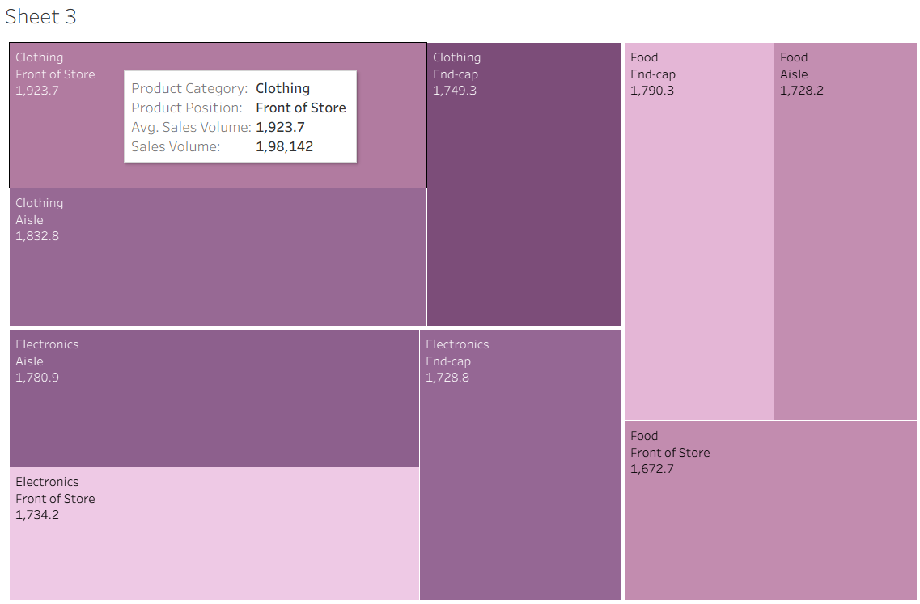

*4.****Consumer Demographics vs  Sales Volume:***

*Graph Name: Consumer Demographics vs Sales Volume. College students contribute the highest sales volume: 4,50,063 units. Followed by Seniors (4,44,089), Young adults (4,31,883), and Families (4,13,276) . Total combined sales volume across all groups is 17,69,311 units.*

*Graph Format:* ***Donut Chart***

*This format clearly shows each demographic group's share of total sales through colored segments.*

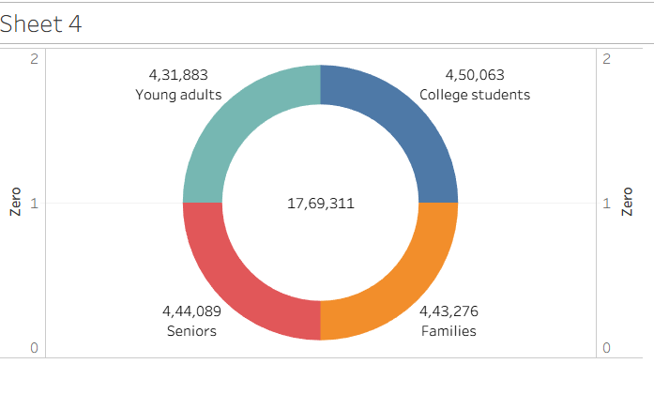

***5.Product Category vs Price:***

*Graph Name: Product Category vs Price. Clothing has the highest average price at 27.75 units.Electronics follow closely at 27.66 units.Food has the lowest average price at 26.47 units.*

*Graph Format****: Pie Chart***

*This chart format is useful for comparing category-wise price shares, showing slight variation in average prices among product types.*

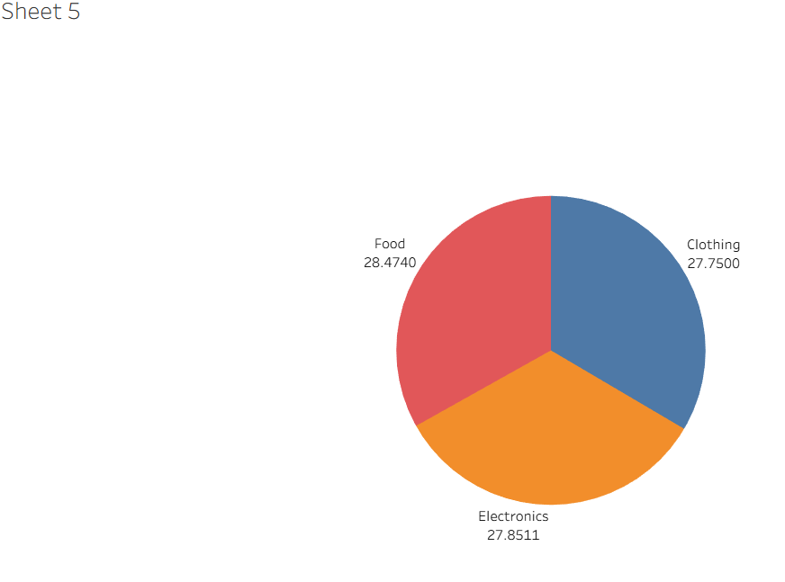

*6.* ***Avg Sales Volume by Product Category by Season***

*Graph Name: Avg Sales Volume by Product Category by Season. Clothing shows high sales in both seasons, with slightly more in non-season (1844.6) than season (1817.1).Electronics have almost equal sales in both conditions, around 1744 (Yes) and 1727 (No).Food performs slightly better in season (1773.2) than non-season (1676.2).*

*Graph Format:* ***Stacked Bar Chart***

*This format displays sales comparison by product category and seasonality, helping to analyze seasonal influence on sales volume.*

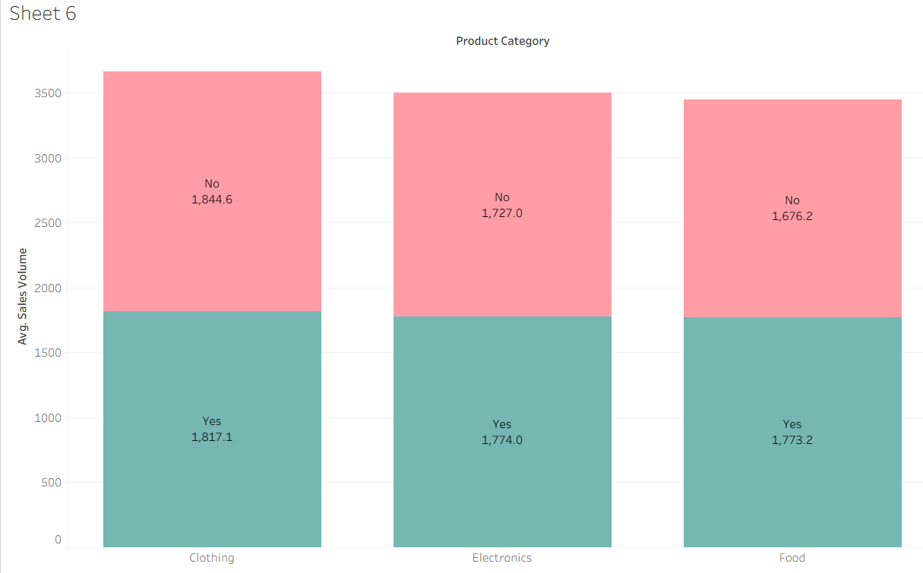

*7.* ***Foot Traffic  by Avg Sales Volume:***

*Graph Name: Foot Traffic by Avg Sales Volume. Low traffic in Aisle has the highest average sales volume at 1900.5 units. High traffic at Front of Store also performs well with 1811.7 units. Medium traffic at End-cap and Aisle show moderate performance, while High Aisle is lower at 1697.2 units.*

*Graph Format:* ***Packed Bubble Chart***

*This format shows foot traffic vs sales volume using bubble size and color to easily compare location and traffic impact.*

*8****.* *Promotion of Product Category on Price and Sales Volume:***

*Graph Name: Promotion of Product Category on Price and Sales Volume With promotion, End-cap has the highest sales volume (1803) and the highest price (31). Without promotion, Front of Store performs best with 1798 sales at a lower price of 27.Promotions generally increase both price and sales volume, especially for End-cap positions.*

*Graph Format****: Text Table***

*This format is ideal for detailed comparison of price and sales figures across positions with and without promotion.*

